# **COMPARISON OF BAD AND GOOD DESIGN**

In this document, we analyze the differences between a poorly designed and a well-designed food menu interface. The improvements made in the good design focus on enhancing user experience, visual appeal, and usability. We will discuss the shortcomings of the bad design and how they were addressed to create a more engaging and effective interface.

# **BAD DESIGN**

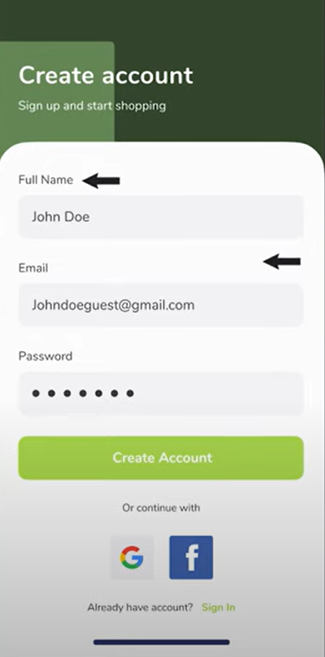

# **NEGATIVES OF THE BAD DESIGN:**

1. Inconsistent Alignment – The labels ("Full Name," "Email," "Password") are left-aligned, but the input fields have different spacing, making the form look unbalanced.
2. Lack of Input Field Borders – The input fields blend too much with the background due to the absence of clear borders or contrasting colors.
3. Arrow Indicators Look Out of Place – The black arrows pointing to the fields are unnecessary and clutter the design.
4. Weak Password Visibility – There's no option to toggle password visibility, which can be frustrating for users.

# **GOOD DESIGN**

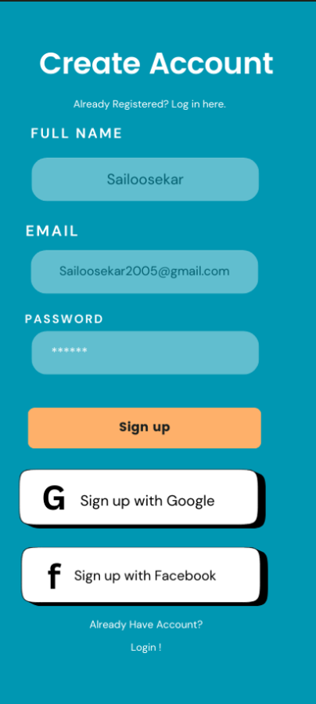

# **IMPROVEMENTS IN THE GOOD DESIGN**

**Improve Readability & Contrast:**

* The background color (teal) and text color should have better contrast for readability.
* The placeholder text inside input fields could be darker to make it more visible.

**Enhance Input Field Design:**

* Input fields should have clear borders or an underline to distinguish them from the background.
* A better visual indicator (e.g., an icon or color change) for active input fields can improve usability.

**Improve Button Design:**

* The "Sign Up" button should have more padding and a slightly darker shade for better contrast.
* The social sign-up buttons should have consistent styling, such as rounded corners and aligned text.

**Better Spacing & Alignment:**

* Increase the spacing between elements to make the form feel less cluttered.
* The social sign-up buttons should be aligned with the rest of the form.

# **CONCLUSION**

The transformation from a bad design to a good design is achieved by focusing on aesthetics, usability, and structure. The good design effectively utilizes colors, typography, images, and layout to create an engaging and user-friendly experience. By incorporating these elements, the interface becomes more appealing and practical for users.